HMDA 2023

Home Loan Approval Prediction
Analysis Report | Data Source: CFPB HMDA Data Browser

Overview
This report presents findings from a machine learning analysis of 4,254,263 real U.S. home purchase loan applications from the 2023 Home Mortgage Disclosure Act (HMDA) dataset, published by the Consumer Financial Protection Bureau (CFPB). Unlike synthetic datasets, HMDA data is legally mandated, every lender in the United States must report every mortgage application, making it one of the most comprehensive and reliable sources of lending data available.
Research question: Can machine learning accurately predict home loan approval decisions using applicant financial and demographic data reported under HMDA?
Target audience: Fair lending compliance teams and regulators who monitor whether denial decisions correlate with protected characteristics such as race, sex, or ethnicity.

Dataset
The 2023 HMDA dataset contains 6,554,532 raw records across 99 columns. This analysis focuses on home purchase loans with a definitive outcome, originated (approved), approved but not accepted, or denied, resulting in 4,254,263 applications after filtering.
- Total applications analyzed: 4,254,263
- Approved (label = 1): 3,614,911 — 85.0% of applications
- Denied (label = 0): 639,352 — 15.0% of applications
- Features after engineering and encoding: 121
- Training set: 3,403,410 rows | Test set: 850,853 rows
The 85/15 class imbalance was handled using class_weight='balanced' across all three models, which up-weights denied applications during training without synthetic oversampling.

Methodology

Feature Engineering
Starting from 26 selected HMDA columns, the following features were engineered:
- income_to_loan_ratio — applicant income divided by loan amount (core affordability signal)
- equity_ratio — (property value minus loan amount) divided by property value
- Log transforms of loan amount, income, and property value to reduce right skew
- DTI encoding — plain integers kept as-is, bracket strings mapped to numeric midpoints
- Age brackets mapped to numeric midpoints (e.g. '35-44' becomes 39)
- 10 categorical columns one-hot encoded: state, race, sex, ethnicity, loan type, lien status, occupancy, credit score type, submission method, and automated underwriting system (AUS)

Models
Three models were trained and compared using 5-fold stratified cross-validation, ranked by ROC-AUC:
- Logistic Regression — interpretable linear baseline
- Random Forest — 300-tree non-linear ensemble
- XGBoost — gradient boosting, selected as best mode

Model Results
XGBoost achieved the best performance with a ROC-AUC of 0.9932 on 850,853 held-out test applications, significantly outperforming the Logistic Regression baseline across all metrics.
Model | Accuracy | F1 (Denied) | F1 (Approved) | F1 Macro | ROC-AUC
Logistic Regression | 78.80% | 0.5007 | 0.8654 | 0.6831 | 0.8270
Random Forest | 95.85% | 0.8728 | 0.9752 | 0.9240 | 0.9929
XGBoost | 96.32% | 0.8767 | 0.9784 | 0.9275 | 0.9932
Table 1. Test set performance for all three models. Values sourced directly from model_comparison.csv

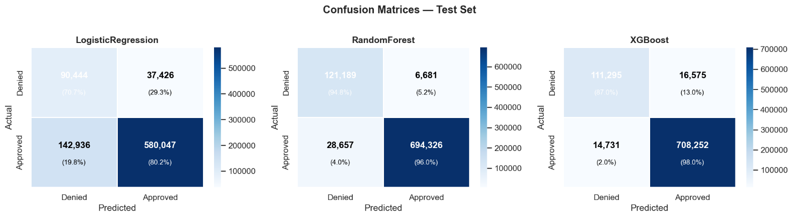
Figure 1. Confusion matrices on the 850,853 test set. XGBoost correctly identifies 87% of denied applications with only 2% false negatives on approved loans.
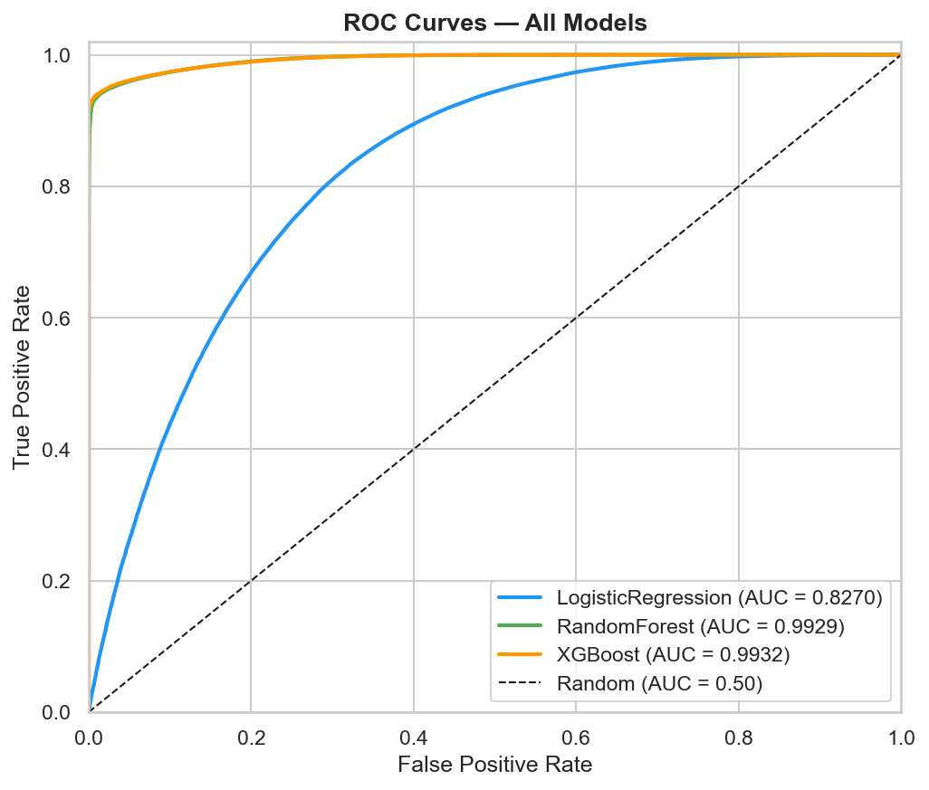
Figure 2. ROC curves for all three models. Random Forest and XGBoost are nearly identical at 0.993, while Logistic Regression trails at 0.827, confirming the non-linear nature of the approval decision.

Key Findings

Interest Rate Dominates Predictions
Interest rate is by far the most predictive feature, accounting for 60% of XGBoost's importance score and 48% of Random Forest's. This is expected, lenders price risk into the interest rate, so the rate effectively encodes creditworthiness. However, this raises a critical fair lending question: if lenders systematically offer higher rates to applicants from certain demographic groups, the model learns to predict denial using a proxy that may already encode potential discrimination.
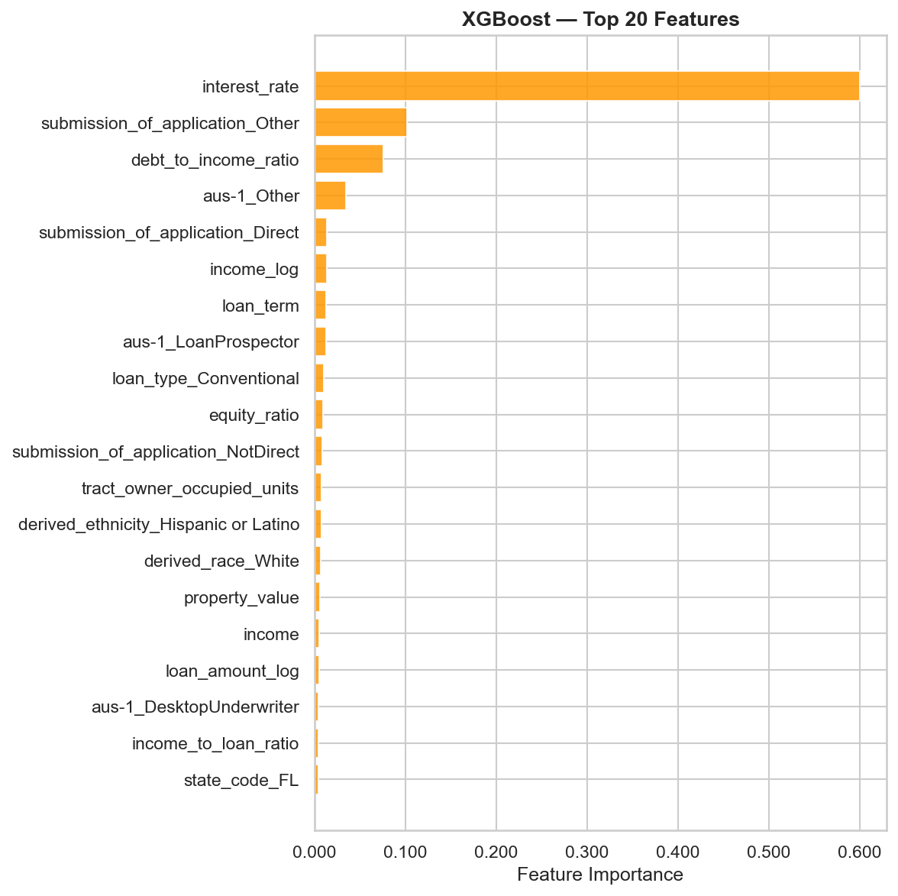
Figure 3. XGBoost feature importance. Interest rate accounts for 60% of predictive power, followed by submission method and debt-to-income ratio.

Debt-to-Income is the Strongest Pure Financial Signal
After interest rate, debt-to-income ratio (DTI) is the most important financial feature in both models. Lenders reported DTI as the primary denial reason in 34.8% of all denied applications, 222,447 cases. The DTI approval rate chart shows that approval remains stable between 83-86% for DTI values below 50%, then drops sharply to around 15% for DTI above 60%, matching standard underwriting thresholds.

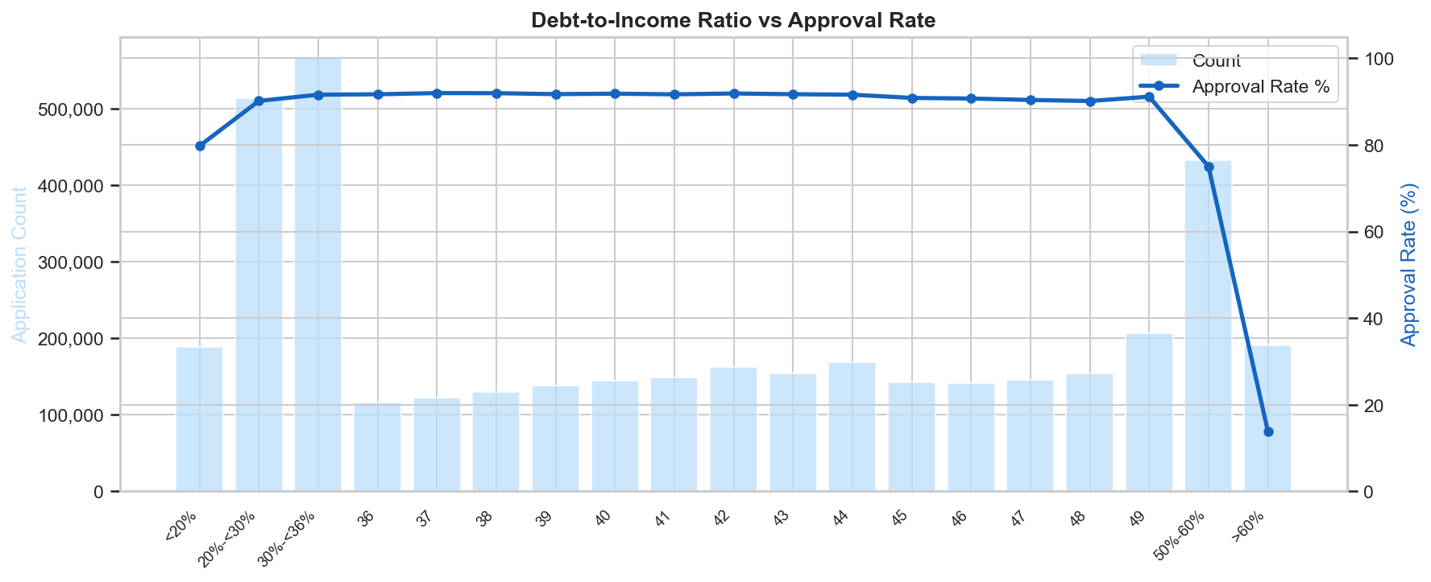
Figure 4. DTI ratio vs approval rate. Approval is stable across the 20-50% range, then collapses sharply above 50%, consistent with standard underwriting guidelines.

Primary Denial Reasons
Among the 639,352 denied applications, debt-to-income ratio and credit history together account for over 62% of all primary denial reasons. Collateral, insufficient property value relative to loan amount, is the third most common reason at 11%.
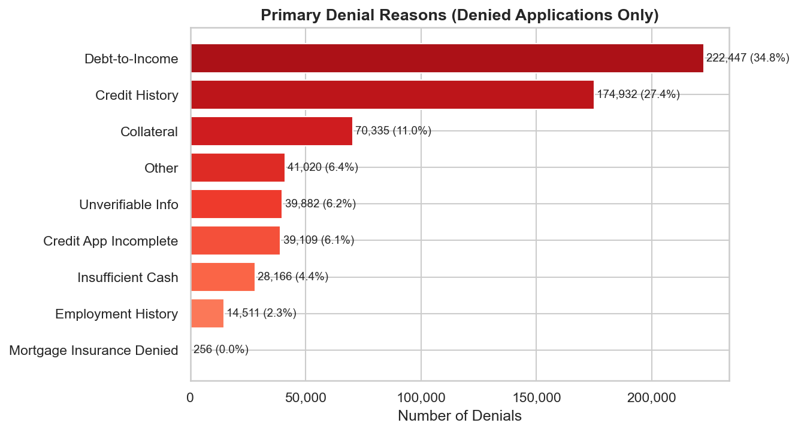
Figure 5. Primary denial reasons. DTI (34.8%) and credit history (27.4%) are the dominant factors.

Racial Disparities in Approval Rates
Raw approval rates vary significantly across racial groups. Asian applicants have the highest approval rate at 88.8%, followed by White applicants at 86.7%. Black or African American applicants are approved at 73.5% and American Indian or Alaska Native applicants at 71.7%, a gap of approximately 17 percentage points compared to the highest group. These raw figures do not control for income, DTI, or loan amount. A full fair lending analysis would require a regression controlling for financial variables to isolate whether race itself is a statistically significant predictor of denial after accounting for legitimate underwriting factors.
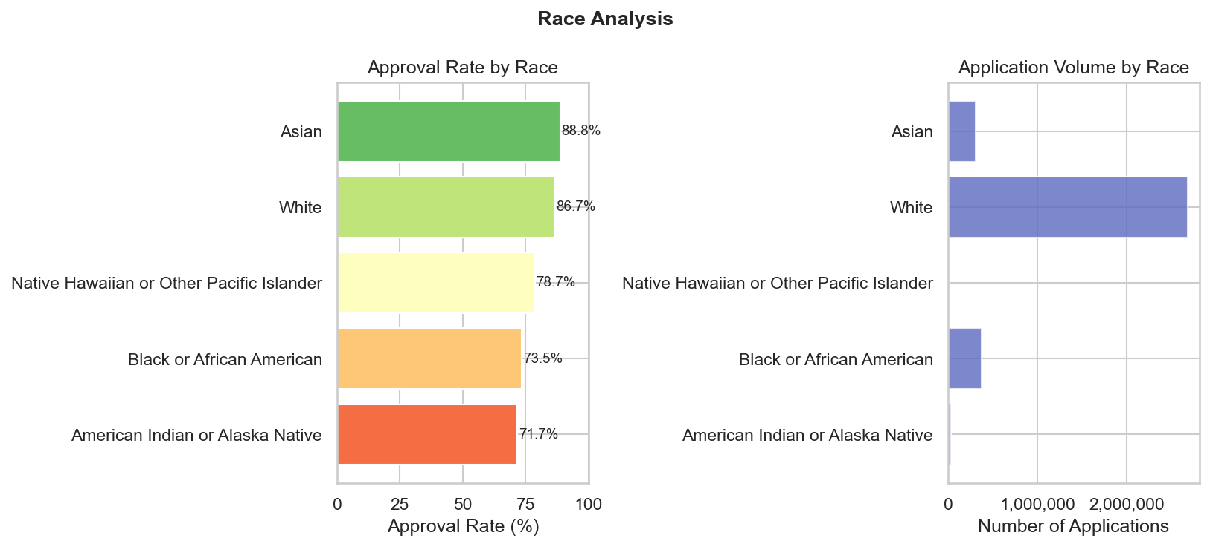
Figure 6. Approval rate and application volume by race. A 17-point gap separates the highest and lowest approval rates. White applicants account for the vast majority of application volume.

Interest Rate as a Fair Lending Concern
Denied applications cluster at higher interest rates with almost no overlap with approved applications. This suggests that by the time an application reaches a denial decision, the interest rate already reflects the lender's risk assessment. All four loan types share similar median interest rates near 6.2-6.7%, with VA loans slightly lower.
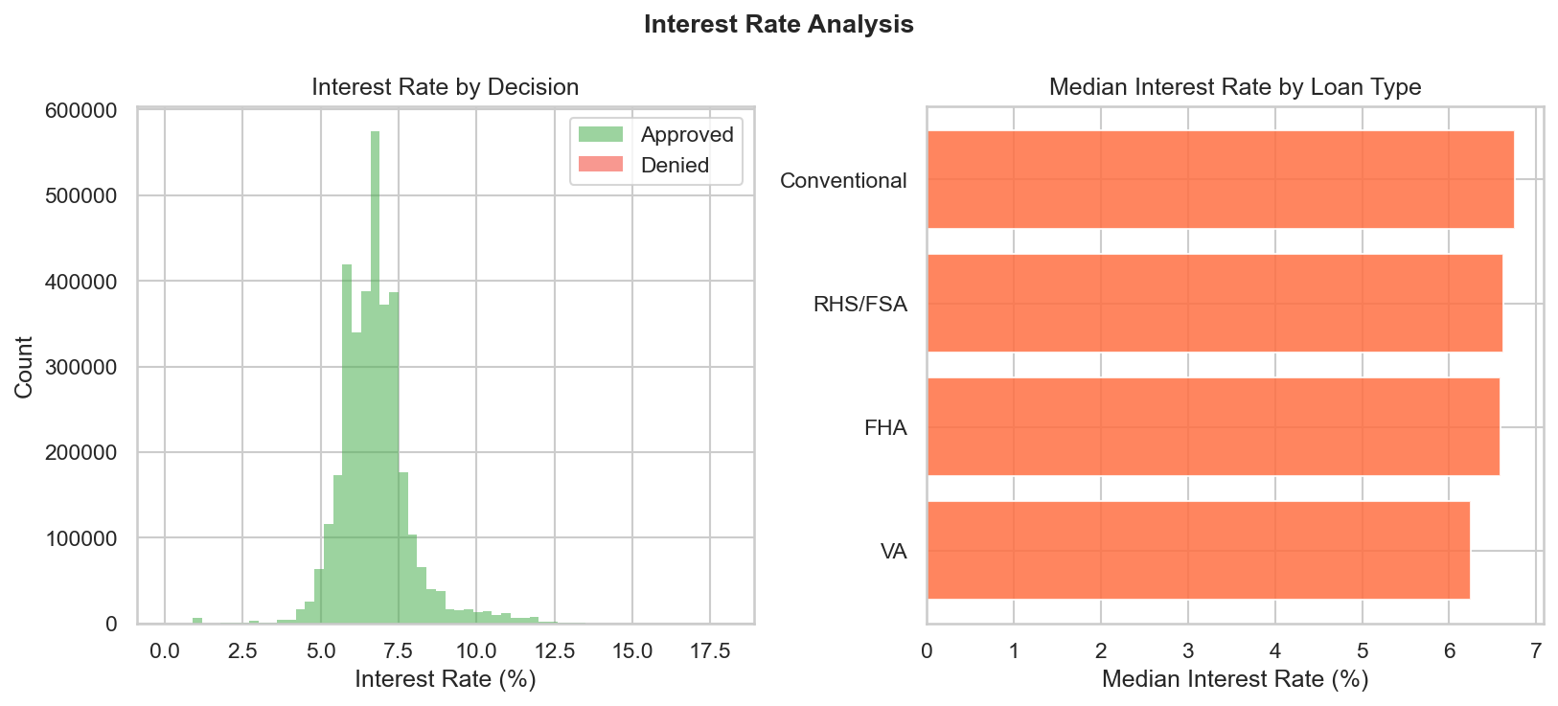
Figure 7. Interest rate by approval decision (left) and median rate by loan type (right). Denied applications show minimal overlap with approved, indicating rate encodes risk at the point of decision.

Limitations & Future Work
- Interest rate as a feature may encode lender bias rather than pure credit risk. A future version should exclude it and measure the performance drop to understand its true contribution.
- Raw approval rate gaps by race do not control for income, DTI, or loan amount. A regression controlling for financial variables is needed to determine whether race has an independent effect.
- The model predicts outcomes as actually reported by lenders, meaning it may replicate existing patterns rather than identify what decisions should be made under fair lending law.
- Geographic variation in approval rates warrants deeper analysis, particularly in states with historically lower approval rates.
The most significant next step is a fair lending regression: fitting the model with race and sex excluded, then comparing predicted denial probabilities against actual outcomes by demographic group. Unexplained gaps between model predictions and actual denials for specific groups would be a meaningful signal of potential disparate treatment

Conclusion
XGBoost achieves a ROC-AUC of 0.9932 on 850,853 real mortgage applications, demonstrating that loan approval decisions are highly predictable from the 121 features available in HMDA data. The near-perfect predictability itself is informative: it suggests that lenders are applying consistent, learnable criteria captured in reported data including interest rate, DTI, and automated underwriting system output.
The 17-percentage-point racial approval rate gap and the dominance of interest rate as a predictive feature together point to the value of deeper fair lending analysis using this dataset. The data and code for this project are publicly available; the HMDA dataset itself is free to download from the CFPB Data Browser at ffiec.cfpb.gov/data-browser.

